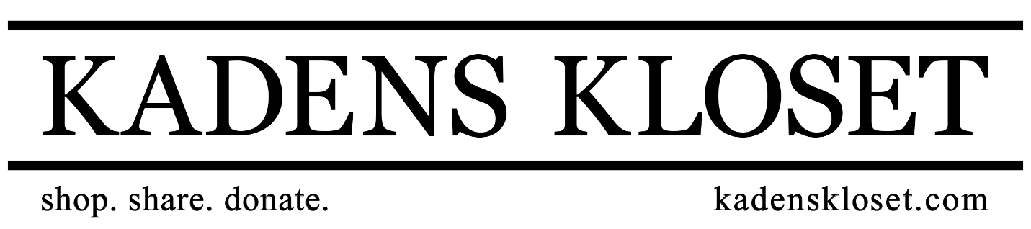
Kadens Kloset Age Out Boxes
A Kadens Kloset Age Out Box is a home warming box filled with home goods and necessities for young adults aging out of the Foster Care System.
Often, these “kids” simply do not have the support system or the family unit in place to help them as they transition into independent living, and this usually occurs at a young age. With our age out boxes, we can help set these young adults up with some of the more essential items they will need to live independently.
Boxes will be packed and distributed to area social workers who will ensure that Young Adults in their jurisdiction receive a box upon their aging out of Foster Care, or moving into their independent living situation. In order to continually be able to provide KK Age Out Boxes, we hope to encourage our communities, churches, local organizations and area businesses to engage in “drives” to help support, collect and provide the materials and items for our boxes.
A Kadens Kloset representative can help spearhead donation drives, speak at donation drive events, help participants understand the need for this resource, and help with fundraising ideas! Organizations are also encouraged to make and pack their own Age Out Boxes, which can be donated to Kadens Kloset who will distribute them to family service providers in the area.

A Kadens Kloset Age Out Box includes:
- Toiletry items such as:
  - shampoo
  - body wash
  - hairbrush or comb
  - deodorant
  - hygiene needs
  - toothbrush/paste
- A towel/washcloth/handcloth set
- A box of dishes
- A silverware set
- A set of measuring cups/spoons
- Small kitchen appliances (hand mixer, can opener, toaster)
- Mixing bowls
- Pillows and a bedding set (sheets, comforter, pillowcase)
- A note of encouragement
- An invitation to shop at Kadens Kloset

